**Business Automation Ltd.**  
MySQL Learning

This file contains basic SQL commands and their functionality.

Here is my main data table. The table contains Name, ID and Email of students.

**Outline:**

* Fetching all data using select.
* Fetching specific field using select.
* Fetch data using alias .
* Show unique data from table.
* Fetching data using where condition.
* Fetching data and use (and, or , not).
* Fetching data and use order by, asc, desc.
* Fetching data by use Limit Offset.
* Fetching data by use Like and Wildcards.
* Condition apply by use in and between.

1. **Fetching all data using select:**

Showing the full table.

* **SELECT** * **FROM** `students`

* **Fetching specific field using select:**

Showing Only name and id of the table.

1. **SELECT** **name**, email **FROM** students;

* **Fetch data using alias:**

Retrieving column information changing the column attribute.

1. **SELECT** email **AS** mail **FROM** students;

* **Show unique data from table:**

Showing the distinct elements of the name column.

1. **SELECT** **DISTINCT** **name** **FROM** students;

* **Fetching data using where condition:**

Showing information if data meet with specific conditions.

1. **SELECT** id, **name**, email **FROM** students
2. **where** id='5';

* **Fetching data and use (and, or , not):**

1. **SELECT** * **FROM** `students`
2. **where** id='5' and **name**='Melody Pollich';

* **Fetching data and use order by, asc, desc:**

1. Showing the students information in ascending order
2. **SELECT** **name**, email **FROM** students
3. **ORDER** **BY** **name**, email **ASC**;

1. Showing the students information in descending order
2. **SELECT** \***FROM** students
3. **ORDER** **BY** **name** **DESC**;

* **Fetching data by use Limit and Offset:**

1. Showing data using limit
2. **SELECT** * **FROM** students
3. LIMIT 5;

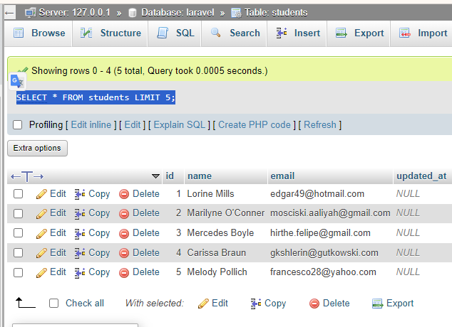

1. Showing data using limit and offset
2. **SELECT** * **FROM** students
3. LIMIT 5 OFFSET 2;

* **Fetching data by use Like and Wildcards**

1. **SELECT** * **FROM** students
2. **WHERE** email LIKE '%gmail%';

* **10.Condition apply by use in and between:**

1. **SELECT** * **FROM** students
2. **WHERE** **name** IN ('Mercedes Boyle');

